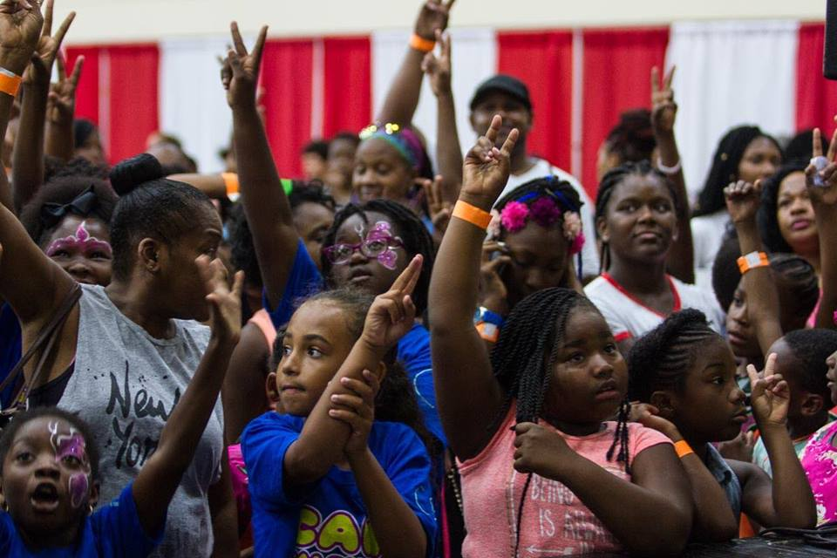

The Urban League model of excellence shines through the affiliates, where each day thousands of determined working men and women, scholars, entrepreneurs, homeowners and advocates participate a diverse array of classes and resources to meet these goals including: college preparatory classes, mentoring activities, STEM education, parental enrichment activities, preparing local residents with skills to help secure employment, training in starting new businesses, homeownership classes, foreclosure prevention, nutrition education, health screenings and help securing health insurance among many others.

**A Message from Leadership**

Dear Friend,

For more than 100 years, the National Urban League has worked to enable African Americans and others to secure economic self-reliance, parity, power and civil rights.

Our board members, leaders in their respective industries, share a commitment to expand the reach and impact of the Urban League Movement across the country in order to empower communities and change lives for the better. Through signature programs in education and youth development, entrepreneurship and business training, housing and community development, and health and quality of life, the Movement implements solutions to create a stronger, more vibrant America.

Thank you for considering becoming a member National Urban League Board of Trustees. We hope you join us.

Sincerely,

Marc H. Morial Michael F. Neidorff

President and CEO Chairman

**MISSION**

Our mission is to enable African Americans to secure economic self-reliance, parity, power and civil rights.

**VISION**

The League promotes economic empowerment through program areas that include education and job training, housing and community development, workforce development, entrepreneurship, health and quality of life.

**National Urban League At-A-Glance**

Founded in 1910 and headquartered in New York City, the National Urban League and our Washington Bureau spearhead the efforts of our local affiliates through the development of signature programs, public policy research and advocacy. The Urban League network of 88 affiliates in 36 states and the District of Columbia provide direct services serving more than two million citizens nationwide.

Today, vast disparities continue to exist in the United States leaving generation after generation facing a never ending cycle of poverty with deficient educational standards, unacceptably high unemployment, limited access to quality healthcare, and deplorable housing conditions.

The National Urban League offers innovative and effective solutions to eliminate our nation’s cyclical poverty by making an investment in our four foundation goals to create a better America for all:

**Our Foundational Goals:**

LEADERSHIP

Marc Morial, CEO

Year Founded: 1910

Budget: $64.4M

Board Members: 43

Employees: 150

Service Area: US – National

UL Affiliates: 88

People Served in 2015: 2M+

____________________________________

FINANCIAL SUMMARY 

Revenue………………………………….$63,045,069

Expenses…………………………………$62,929,157

Net Income……………………………...….$115,912

____________________________________

FUNDING SOURCES 

Corporations + Foundations…...$18,060,000

Government…………………..……....$17,082,430

Sponsorships………………………..…..$4,485,000

Events……………………………………….$1,500,000

Individuals…………………………………...$826,000

With our valued partners, we open doors of opportunity and help build a strong, talented workforce, businesses and stable communities that benefit us all. A selection of National Urban League partners includes: Shell Oil Company, Centene, Nationwide, Bank of America, Wells Fargo, AT&T, UPS, Verizon, GEICO, AEP, BP, Comcast, JPMorgan Chase, PepsiCo, Toyota, Walmart, Citibank, MasterCard, American Express, ABM, Aramark, and Macy’s.

Education & Youth Development

Every American child is ready for college, work, and life

Jobs, Entrepreneurship, & Business Development

Every American has access to jobs with a living wage and good benefits

Housing & Community Development

Every American lives in safe, decent, affordable and energy-efficient housing on fair terms

Health & Quality of Life

Every American has access to quality and affordable healthcare solutions

**Role of the National Urban League Board Member**

*Urban League Board Responsibilities*

* Attend all Board meetings, two in-person and one via conference call
* Understand the organization – its mission, goals, objectives, services and programs
* Champion the cause through active involvement
* Participate fully and openly in meetings – sharing insights, ideas and suggestions
* Serve on committees and accept special assignments as requested and as possible. Committee include:
  + Executive
  + Finance
  + Audit
  + Governance
  + Programs
  + Compensation
  + Development
  + Affiliate Services
  + Marketing and Communications
  + Policy
* Suggest possible nominees to the Board who can make significant contributions to the work of the Board and the organization
* Partner with NUL in programs/initiatives/events over a 3-year term

*Fiduciary and Financial Responsibility*

* Assist the Board in carrying out its fiduciary responsibilities, such as reviewing the organization's annual financial statements
* Make a personal contribution to the Annual Board Campaign, commensurate with capacity

**URBAN LEAGUE IMPACT**

PROGRAM STATS 2005-2015

*Clients Served*

Education: 2.43M

Jobs/Housing 3.68M

Health 7.91M

Civic Engagement 5.14M

Other Programs 1.88M

*Economic Impact* 

2015 $1.5 billion

2005-2015 $16.4 billion

____________________________________

2015 PROGRAM STATS

*Employment Programs* 

# of participants 56,549

Individuals placed in jobs 29,036

*Housing Programs*

# counseled in Home Ownership 10,691

# of Homes purchased 1,588

*Entrepreneurship Programs*  

# participants 15,680

# of New Businesses created 6,074

Sales of all businesses $109.8M



Harry E. Johnson, Sr.

Julia Johnson

Lawrence S. Jones

Louis B. Lynn, Ph.D.

James E. Mahoney

Lamell McMorris

Tim Murphy

J. Brandon Neal

Marvin Odum

Nicholas Perkins

William F. Pickard, Ph.D.

Rynthia Rost

Jabar Shumate

The Honorable Rodney E. Slater

Cynthia M. Stokes-Murray

Valerie Thompson, MBA, Ph.D.

Lela Wingard

Lanesha Anderson

Kendrick F. Ashton, Jr.

Claire Babineaux-Fontenot

Khary P. Barnes

Lisa Barton

Robert J. Brown

James H. Buford

Kenneth D. Bynum

Carlos J. Clanton

David L. Cohen

Victor Crawford

Jeff Davis

Ray Dempsey, Jr.

Donna Epps

Myron Gray

John D. Hofmeister

Carol Jackson

Wil James

Latrisha Jemison

**Benefits of Board Membership**

* Membership on one of the most diverse boards in the country
* Participate in networking opportunities with leaders in the business and public sectors (former public officials and cabinet officers, industry leaders)
* Enhance corporate brand reputation
* Share your talents and unique perspective in support of an impactful cause
* Contribute to a timely and robust conversation about public policy, diversity and business trends
* Build relationships that help advance your future goals
* Collaborate with a strong management team

**Trustees**

Thank you for considering joining the National Urban League Board of Trustees.

**BOARD LEADERSHIP**

**CHAIR**

Michael F. Neidorff

Chairman, President and CEO

Centene Corporation

**SENIOR VICE CHAIR**

The Honorable Alexis M. Herman

President

New Ventures

**TREASURER/VICE CHAIR**

Jon R. Campbell

EVP, Director of Social Responsibility Group

Wells Fargo & Company

**VICE CHAIR**

Gale V. King

Executive Vice President

Chief Administrative Officer

Nationwide

**SECRETARY**

Charlene Lake

Senior Vice President

Public Affairs & Sustainability Officer

AT&T

**VICE CHAIR**

John W. Mack

Los Angeles Planning Commission

**PRESIDENT AND CHIEF EXECUTIVE OFFICER**

Marc H. Morial

National Urban League, Inc.



